

**CN LAB**

**NAT**



November 24, 2023

M. Muntazer Mehdi

**Static Nat**

**Task 1:**

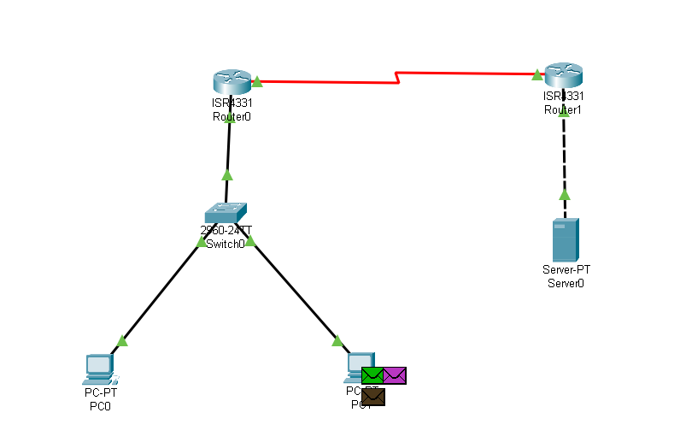

**Router 0:**



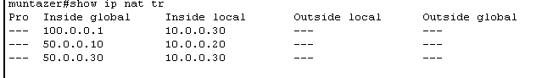

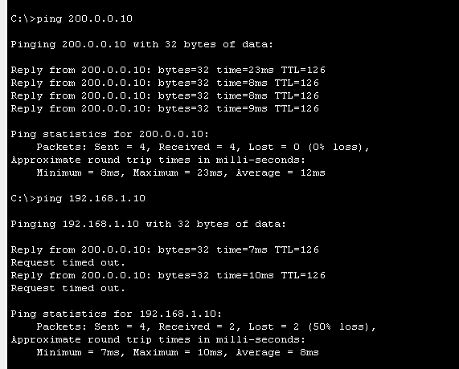

**Router 1:**

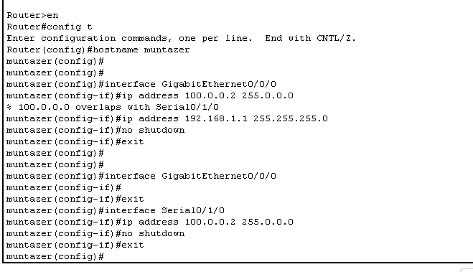

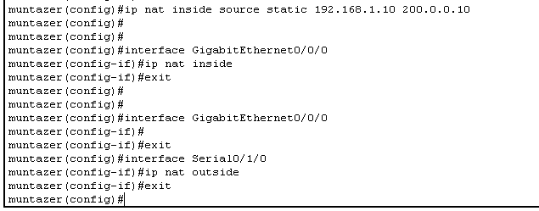



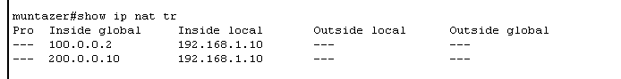

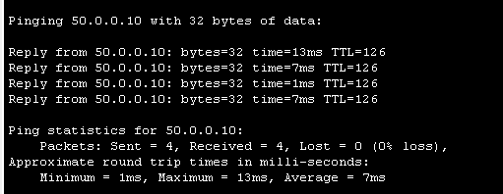

**Dynamic Nat:**

**Task 2:**

**Router 0:**

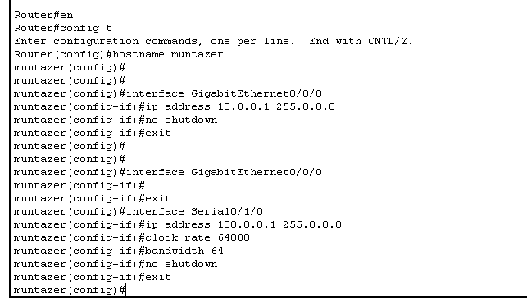

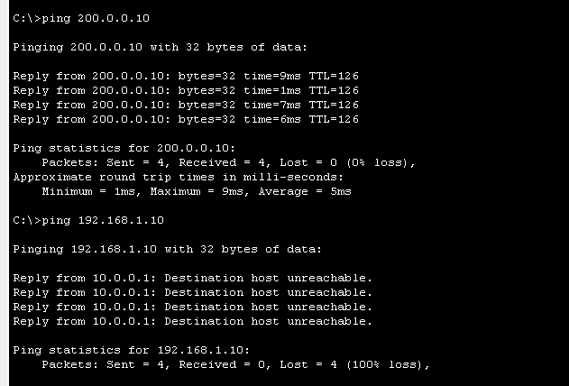

**Router 1:**

